**Logical reasoning (set 3)**

**Company name: Mphasis No. of Question: 25**

**1:** What will come at the place of question mark?

F: 441:: L: ?

1. 196
2. 484
3. 676
4. 225

**Answer:** option d

**Solution :**

F = 6 : 441 = (27 – 6) 2

L = 12 : 225 = (27 – 12) 2

**2:** Select the correct combination of mathematical signs to replace * signs and to balance the given equation:

36 * 12 * 3 * 6 * 34

1. ÷ + =
2. + ÷ – =
3. + × = ÷
4. × = +

**Answer:** option b

**Solution :**

Given that:

36 * 12 * 3 * 6 * 34

After applying, + ÷ – =

36 + 12 ÷ 3 – 6 = 34

⇒ 36 + 4 – 6 = 34

⇒ 40 – 6 = 34

⇒ 34 = 34

**3:** Choose the term which is not like the other term in a group?

1. 8 - 5
2. 12 - 7
3. 90 - 46
4. 124 - 61

**Answer:** option d

**Solution :**

8 – 5 = 8/2 + 1 = 5

12 – 7 = 12/2 +1 = 7

90 – 46 = 90/2 +1 =46

124 – 61 = 124/2 +1 = 63 $≠$ 61

**4:** In a certain code language, TIN coded as 48 and TAX coded as 50. So, find the code for TOPS?

1. 72
2. 69
3. 75
4. 74

**Answer:** option c

**Solution :**

TIN = 20 + 9 + 14 = 43 + 5 = 48

TAX = 20 + 1 + 24 = 45 + 5 = 50

TOPS = 20 + 15 + 16 + 19 = 70 + 5 = 75

**5:** In the following question select the number pair which is not related to the given pair.

(2753 : 4523)

1. 2375 : 4523
2. 5213 : 2742
3. 7532 : 4253
4. 2375 : 5327

**Answer:** option d

**Solution :**

(2753 : 5372) & (2375 : 5327) All are made by the using (2357) but in all other option and question nos. pair there is use of 4 also.

**6: DIRECTIONS:**Find the Mirror image of the figure:

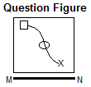

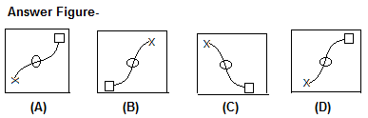

1. A
2. B
3. C
4. D

**Answer:** option b

**Solution :**

B

**7:** In the following series given with one term missing. Choose the correct alternative from the

given ones that will complete the series.

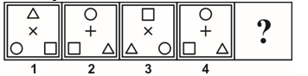

1. 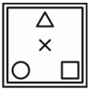
2. 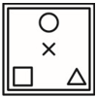
3. 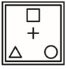
4. 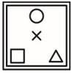

**Answer:** option a

**Solution :**

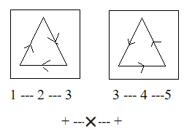

**8:** Find the missing number?

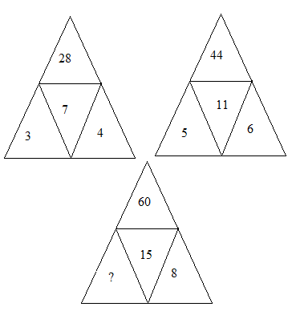

1. **9**
2. **8**
3. **7**
4. **6**

**Answer:** option c

**Solution :**

3 + 4 = 7 = 7 × 4 = 28

5 + 6 = 11 = 11 × 4 = 44

? + 8 = 15 = 15 × 4 = 60

? = 15 – 8 = 7

**9:** In a row of boys, they are looking north. Ganesh is at the seventh place on the left side of Akshay. Vijay, who is 20th from left, is in the 7th position from the right of Akshay. If Kamlesh, sitting at third place from the right side of Ganesh, is at 20th place from the right side of the row. Find out the number of boys in the row?

1. 26
2. 28
3. 30
4. Cannot be determined

**Answer:** option b

**Solution :**

**10 :** If ‘a’ is on the top of the dice then which side of the dice will come into the bottom side?

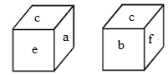

1. B
2. C
3. F
4. E

**Answer:** option c

**Solution :**



**11:** How number of rectangles (excluding squares) present in this following figure?

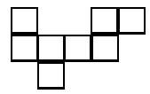

1. 9
2. 8
3. 10
4. 7

**Answer:** option c

**Solution :**

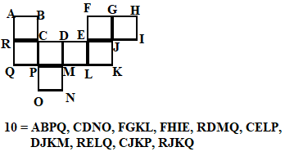

**12:**

Which of the two conclusions can be concluded on the basis of given statements?

**Statements:**

All desks are table.

All table are chair.

No table is mirror.

All pens are chair.

**Conclusion:**

Some pen being a desk is a possibility.

Some chairs are not mirror.

1. Conclusion 1 is correct.
2. Either Conclusion 1or 2 is correct.
3. Conclusion 1 and 2 are both correct.
4. Conclusion 2 is correct.

**Answer:** option c

**Solution :**

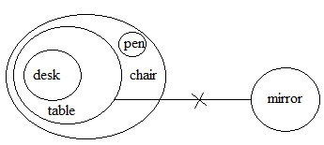

**13:** S is the daughter-in-law of Z and sister-in-law of R. M is the son of Z and only brother of R. How is S related to M?

1. Sister-in-law
2. Aunt
3. Cousin
4. Wife

**Answer:** option d

**Solution :**

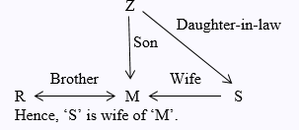

**14:** Which one word can be formed by using these following letters?

R R T T T N N O O A A P I S

1. Elephantiasis
2. Translation
3. Transgenesis
4. Transportation

**Answer:** option d

**Solution :**

‘Transportation’ can only be formed by using ‘R R T T T N N O O A A P I S’.

**15:** Select an alternative from figure (i), (ii), (iii) and (iv) which contain symbols to exactly make the problem figure (X).

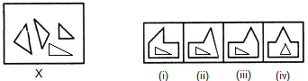

1. (i)
2. (ii)
3. (iii)
4. (iv)

**Answer:** option c

**Solution :**



Figure (iii) contains all the symbols of figure (X).

**16:** Arrange the given words in the sequence in which they occur in dictionary?

(1) Miracle  
(2) Minority  
(3) Mirror   
(4) Mind

1. 2341
2. 4213
3. 4312
4. 2314

**Answer:** option b

**Solution :**

According to dictionary,

(4) Mind  
(2) Minority

(1) Miracle   
(3) Mirror

**17:** In the following question, select the number which can be placed at the sign of question mark (?) from the given alternatives.

AZY, BYX, CXW, DWV, ?

1. ECX
2. FWD
3. EVU
4. EDC

**Answer:** option c

**Solution :**

Clearly,

1st letter A +1 B +1 C +1 D +1 E

2nd letter Z -1 Y -1 X -1 W -1 V

3rd letter Y -1 X -1 W -1 V -1 U

So, missing term = EVU

**18:** At sunrise, Aman stood in front of Ashok. He found that the shadow of Ashoka is on its right hand. Find out which direction would Aman looking at in the following direction?

1. North
2. South
3. East
4. West

**Answer:** option b

**Solution :**

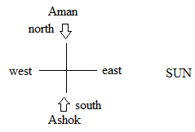

**19:** In a certain code language CHAIR is written as EGCHT so find the code for AUDIT?

1. CTFHU
2. CTFVH
3. CTFHV
4. CTFUH

**Answer:** option c

**Solution :**

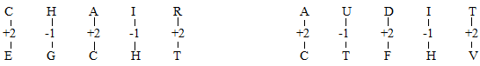

**20:** Which of following diagram shows the correct relationship between House, Bridge and Bricks?

1. 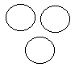
2. 
3. 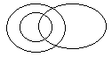
4. 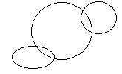

**Answer:** option d

**Solution :**

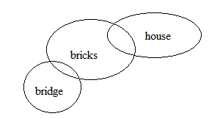

**21:** Just like grains belong to the storage house. What is the water related to it?

1. Sea
2. Dam
3. River
4. Drinking

**Answer:** option b

**Solution :**

The storage house is used for the storage of grains; similarly the dams are used to store water.

**22:** In a certain code language, VIJAY coded as UJIBX. So, find the code for AMAN?

1. NAMA
2. BNNZ
3. ZNZO
4. ZNZP

**Answer:** option c

**Solution :**

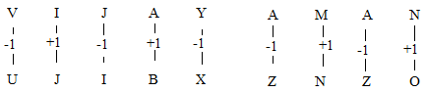

**23:** Six friends A, B, C, D, E, and F are sitting on the corners of the hexagonal table for playing a card according to the following.

1) F sits opposite to A and immediate right of B.

2) D is an immediate neighbor of A and B and sits opposite to C.

Find who sits opposite to E?

1. A
2. B
3. C
4. D

**Answer:** option b

**Solution :**

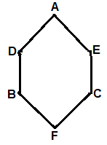

**24:** In the following question, four words are given, three of which are similar in some way,

while the fourth is different. Choose the odd word.

1. RUSTY
2. SEVEN
3. SPRINT
4. EIGHT

**Answer:** option b

**Solution :**

One or two different 'Vowel' letters are used in all other groups whereas in the alternative (B) the

letter 'E' has the same 'Vowel' letter used So, option (2) is correct.

**25:** In the following question, a sheet of paper (square/circle/triangle) is folded and punch (cut) is made. When unfolded the paper sheet looks sheet like the question figure. Analyses the answer figure and select the one that follows the manner in which the paper is folded and punch is made.

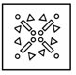

1. 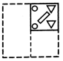
2. 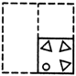
3. 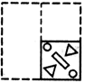
4. 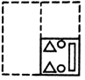

**Answer:** option c

**Solution :**

So, option (3) is the correct answer.